**Project Documentation**

*Java Applications – Lecture Homework*

Prepared by:

* Mikhael Nabil Salama Rezk (IHUTSC)
* Szabó Lilla (BDCRL0)

# Table of Contents

Table of Contents 1

Project Overview 1

GitHub and OANDA Account Information 2

Theme Selection 2

Main Page Menu 2

SOAP Menu 4

Forex Account Menu 6

Forex-ActPrice Menu 9

Forex-HistPrice Menu 11

Forex-Open Menu 11

Forex-Pos Menu 13

Forex-Close Menu 14

GitHub Version Control 15

System Architecture and Implementation Details 15

Testing and Results 16

Conclusion and Future Enhancements 16

# Project Overview

This documentation presents a complete overview of a Java Spring Boot web application developed as part of the 'Java Applications – Lecture Homework' course assignment. The project demonstrates the implementation of a server-side web application that communicates with the Hungarian National Bank’s (MNB) SOAP-based web service to retrieve and visualize foreign exchange (Forex) data.

The project runs locally (localhost) as a Spring Boot application with MVC pattern, templating using Thymeleaf, and static assets for presentation.  
The project is packaged as an executable JAR file named homework.jar.

*The documentation includes system architecture, module descriptions, setup and run instructions, testing notes, and screenshots*.

# GitHub and OANDA Account Information

GitHub Repository URL:

OANDA Account Username:

OANDA Account Password:

# Theme Selection

For the frontend design, a free responsive theme called 'Massively Design' from <https://html5up.net/> was applied. This theme provides a modern, mobile-friendly layout and was customized to fit the Forex web application. It is located under the directory: src/main/resources/static/theme/massively-design/.

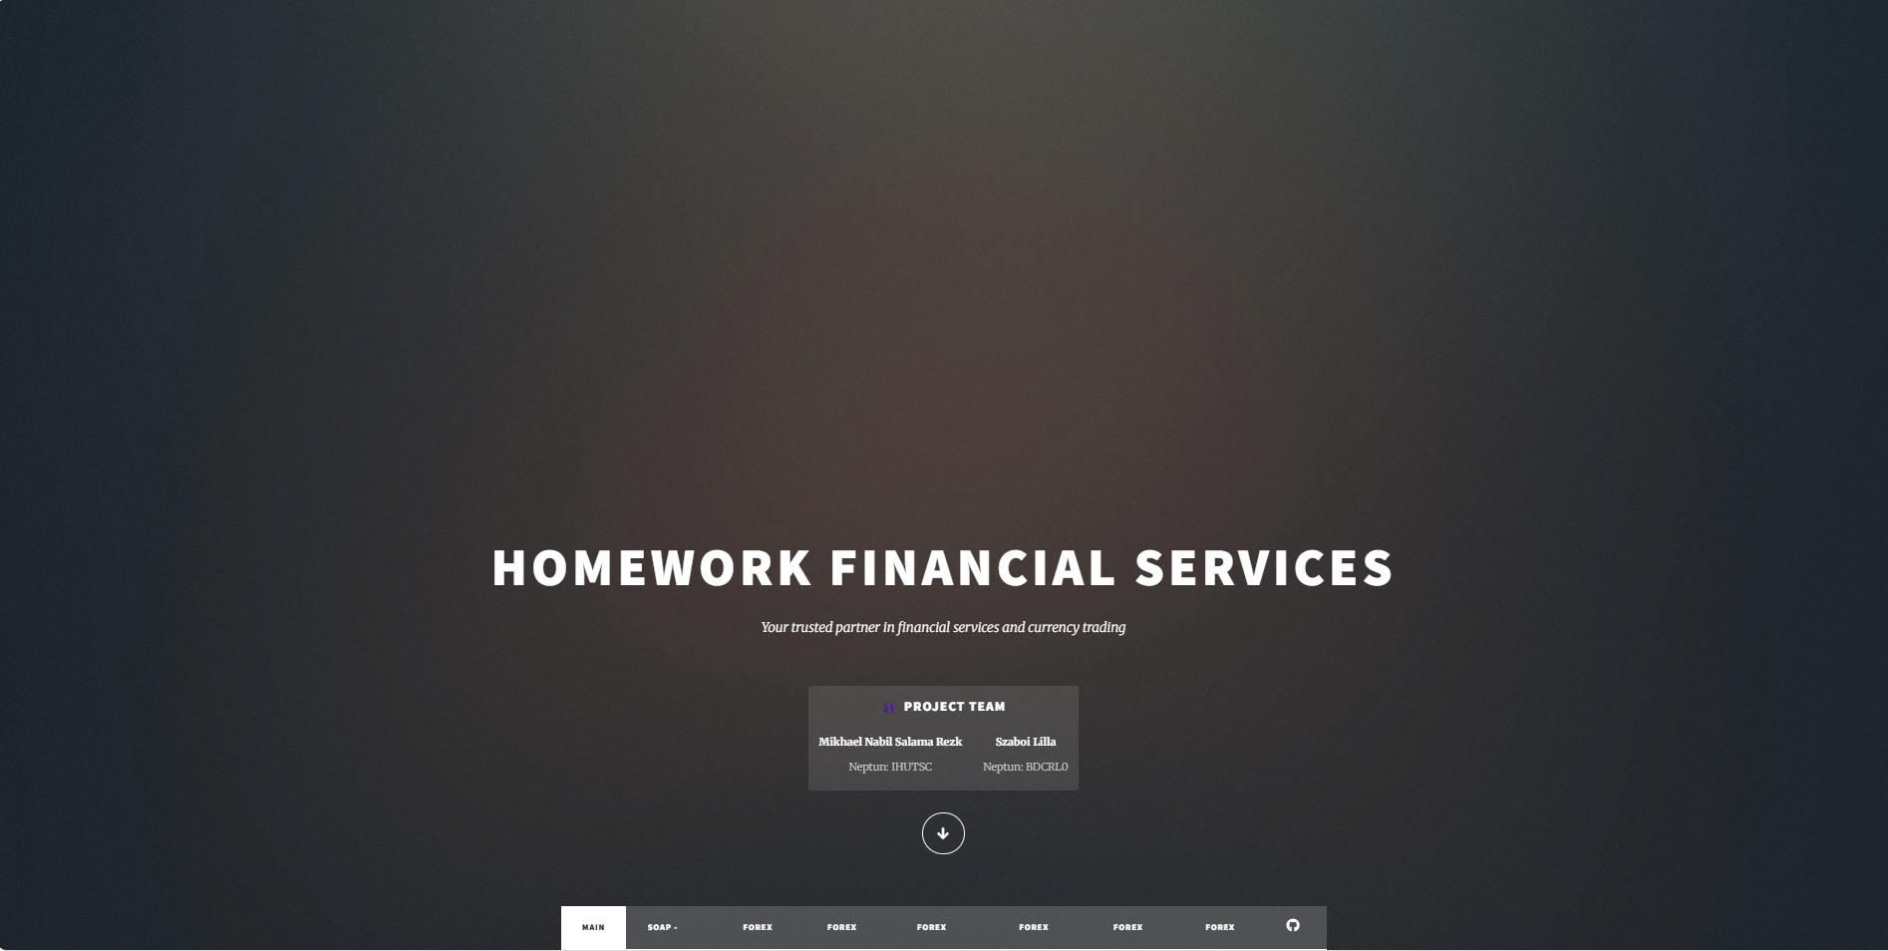

# Main Page Menu

The Main Page Menu introduces the fictional company offering Forex-related services and provides an overview of the system’s main features. It serves as the starting point for navigating the web application.

The page includes a short welcome section that describes the purpose of the project *(to demonstrate various Forex functions and data integrations using Java Spring Boot)*. Below this introduction, several menu options allow users to access different parts of the system, each corresponding to a task from the project description:

* **Real-Time Market Prices** – leads to the Forex-ActPrice page.
* **Historical Price Analysis** – opens the Forex-HistPrice page.
* **Open Trading Positions** – directs to the Forex-Open feature.
* **Portfolio Management** – provides access to Forex-Pos and Forex-Close menus
* **Currency Data from the Hungarian National Bank** – links to the SOAP Menu
* **Forex Account Management** – opens the Forex Account Menu.

Each menu option is displayed with a simple, responsive design, making it easy for users to move between pages and explore all the implemented project functions.

**Main Menu Welcome**: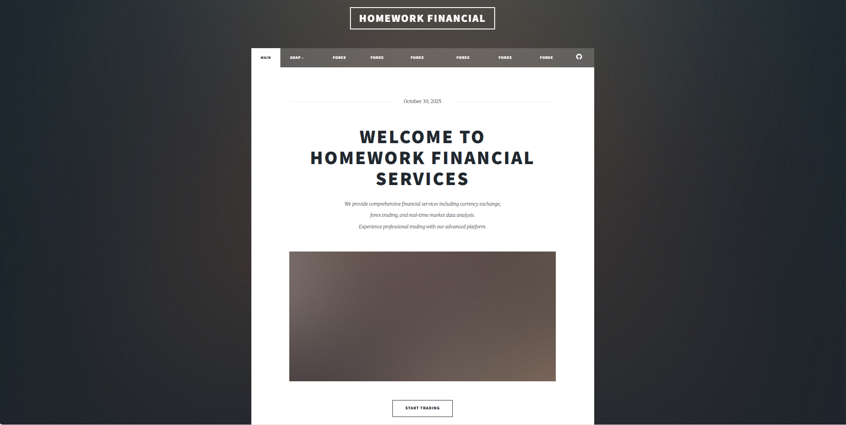

**Main Menu 1**: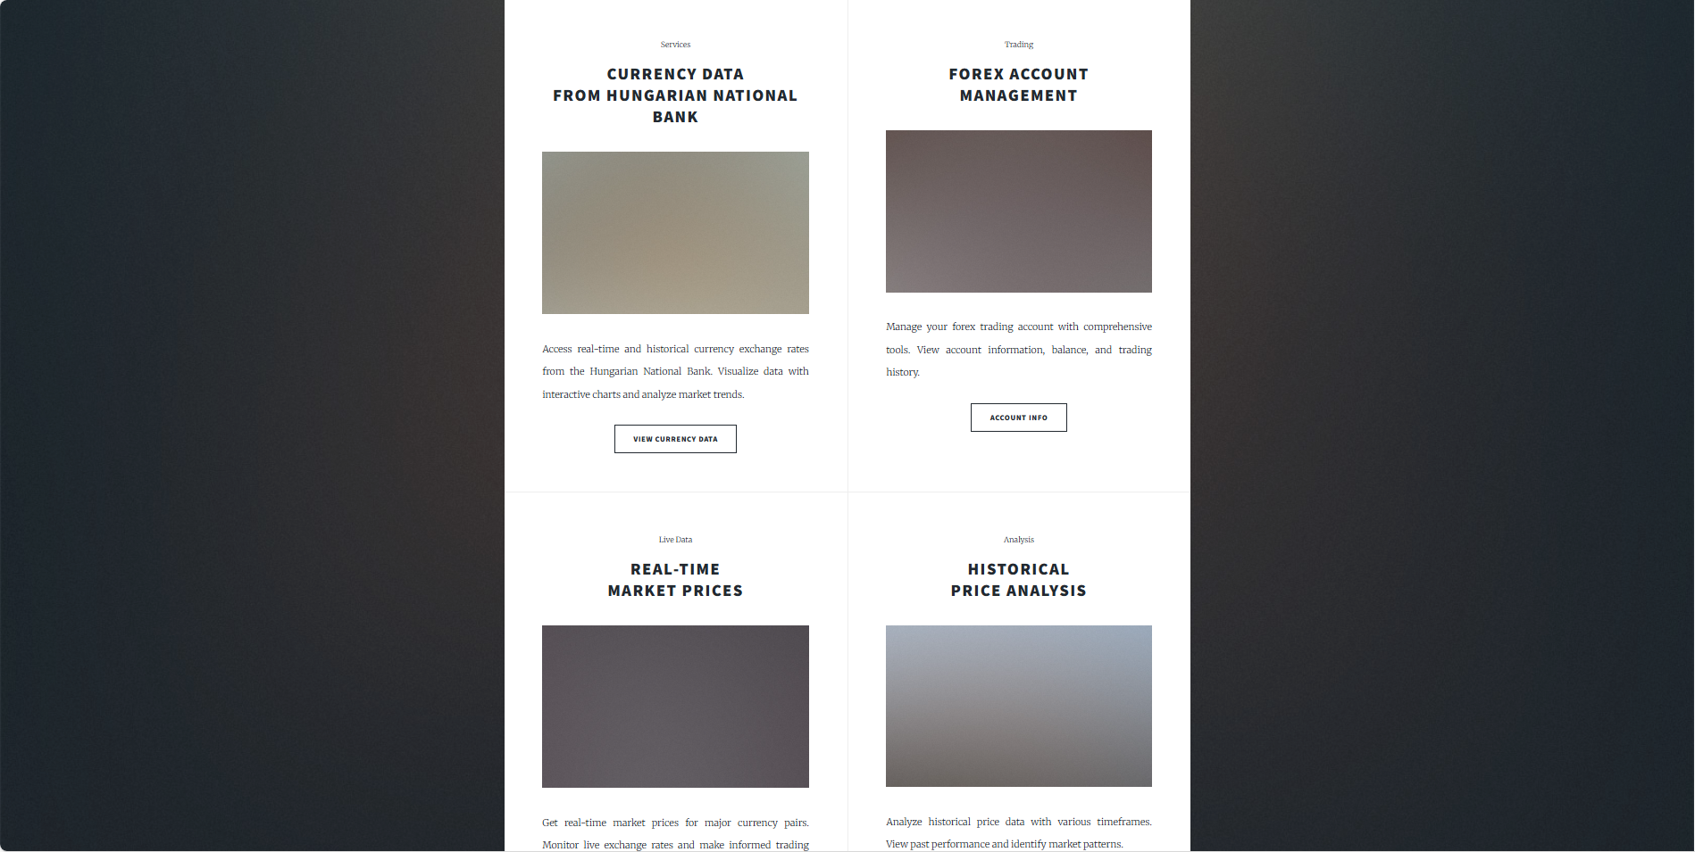

**Main Menu 2**: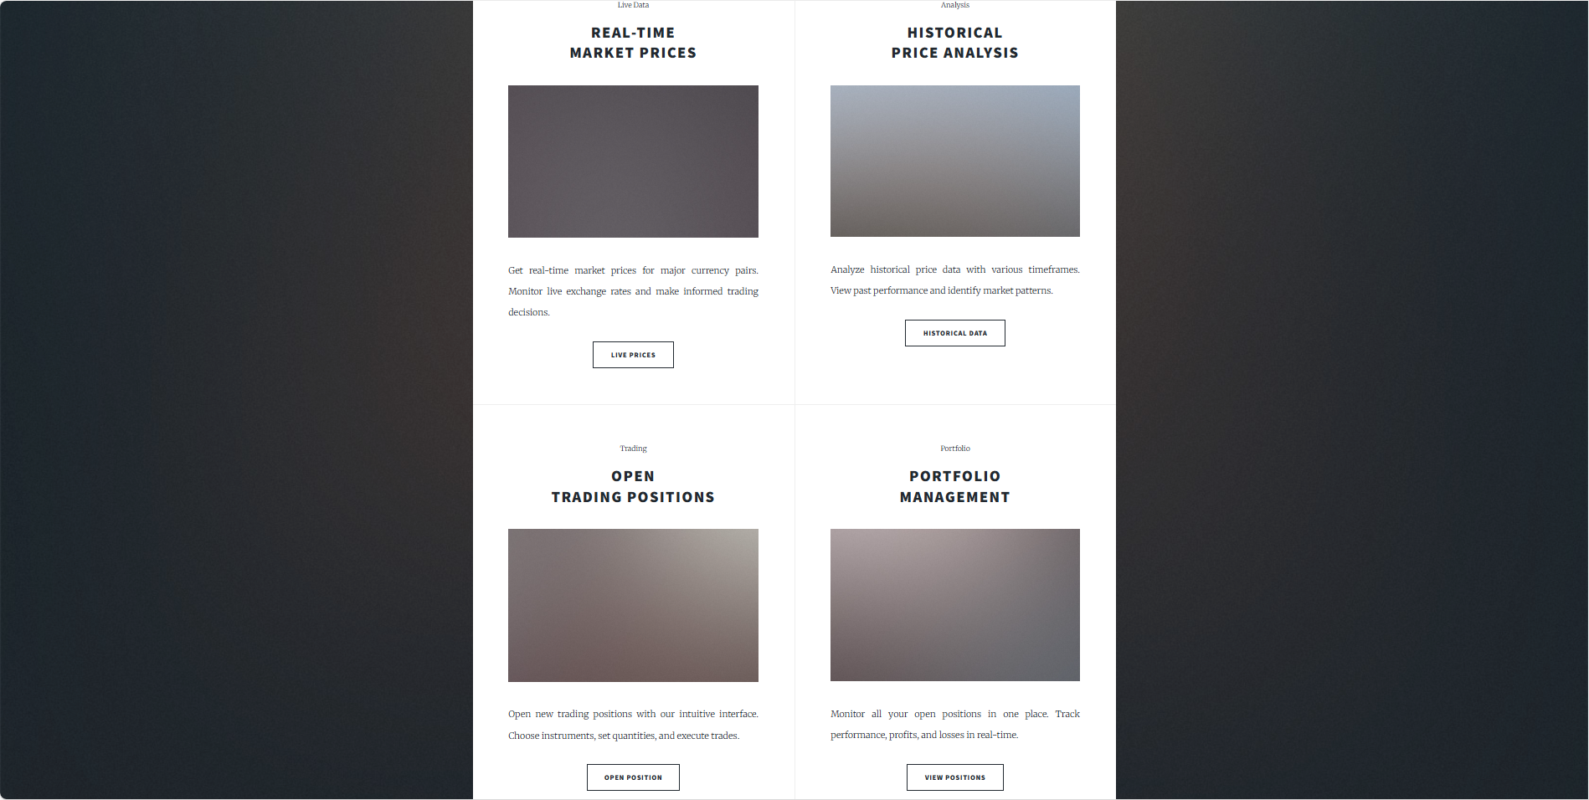

# SOAP Menu

The SOAP Menu connects to the Hungarian National Bank’s (MNB) web service to display official currency exchange rates.

At the top of the page, users are greeted with a welcome message titled “Hungarian National Bank Currency Exchange Rates.” Below the heading, the interface includes:

* A **drop-down list** for selecting a currency (for example, EUR or USD)
* Two **date selectors** to set the start and end dates for the query period.

After submitting the request, the system uses the built-in SOAP client to fetch exchange rate data from the MNB service. The retrieved data is displayed in a structured HTML table, showing:

* **Date** of each record
* Chosen **currency**
* Exchange **rate**

Under the table, a Chart.js graph visually represents the same data, allowing users to easily observe how the currency changed over time. This chart provides an interactive and easy-to-read overview of historical trends.

The page also includes a custom footer, designed in the same style as the rest of the site, to keep the layout consistent and provide navigation or additional information.

Overall, this menu combines data retrieval, visualization, and responsive design in a simple, informative interface.

**SOAP Greeting**: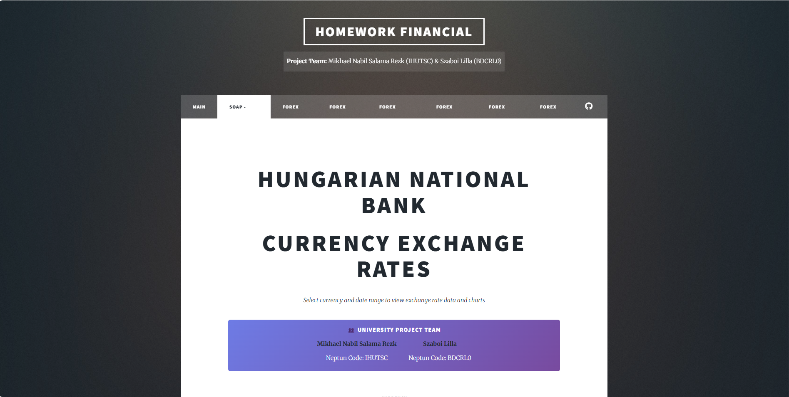

**SOAP Drop Down**:

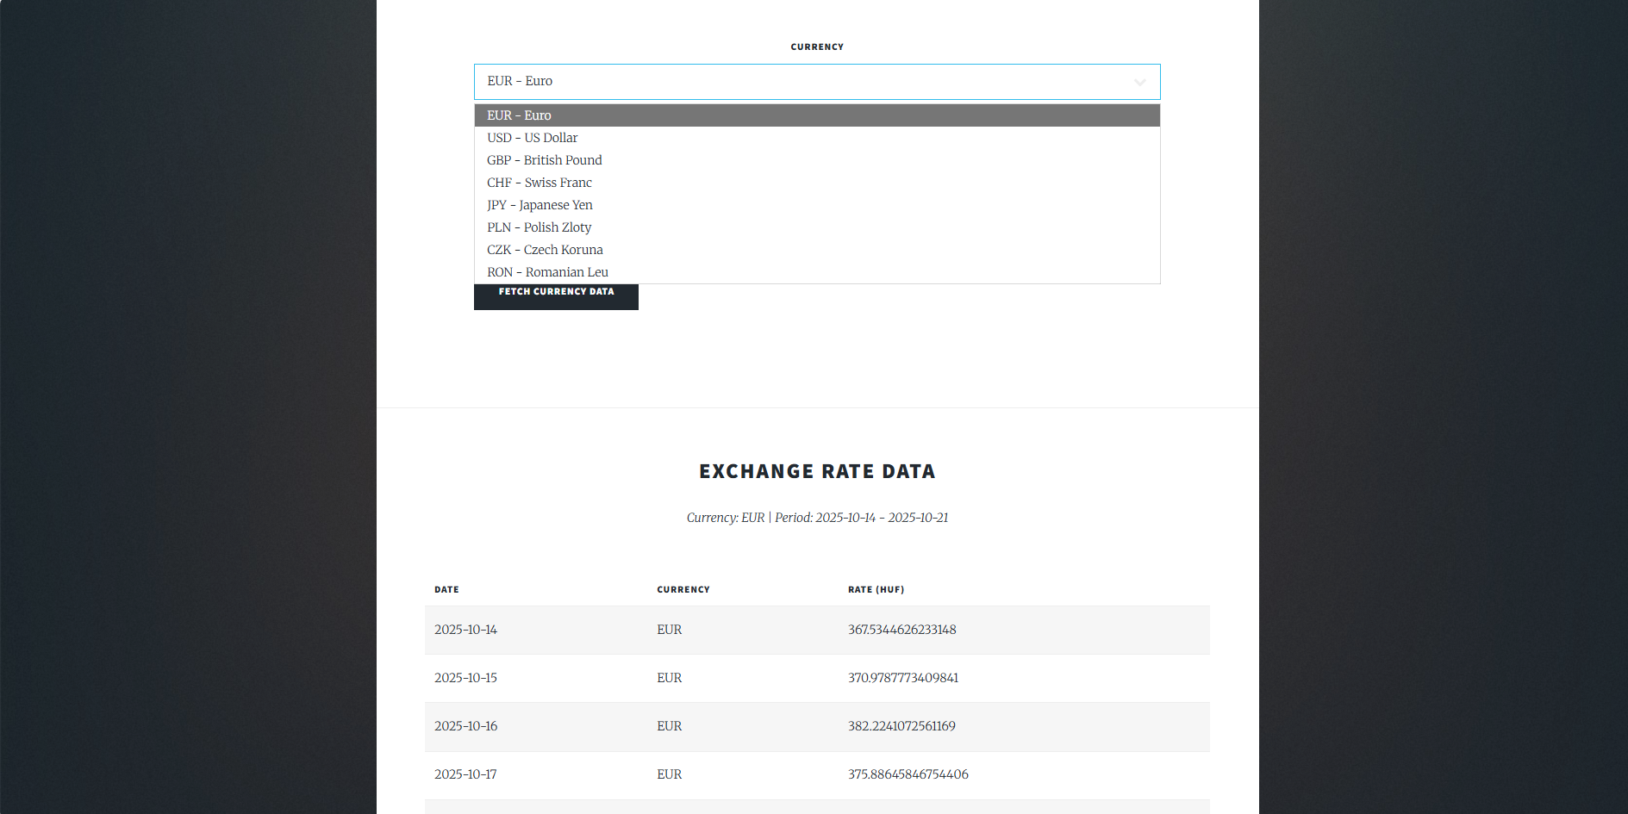

**SOAP Start and End date**:

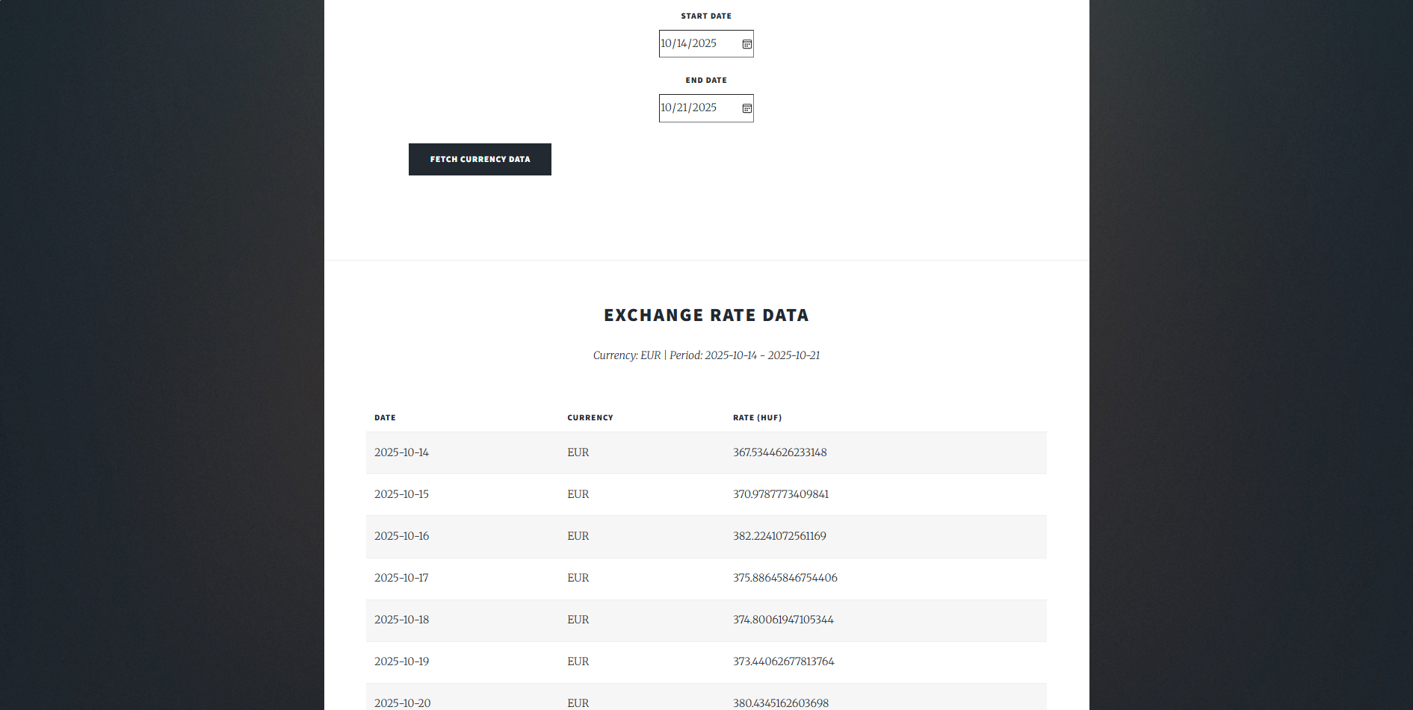

**SOAP Table**:



**SOAP Chart**:

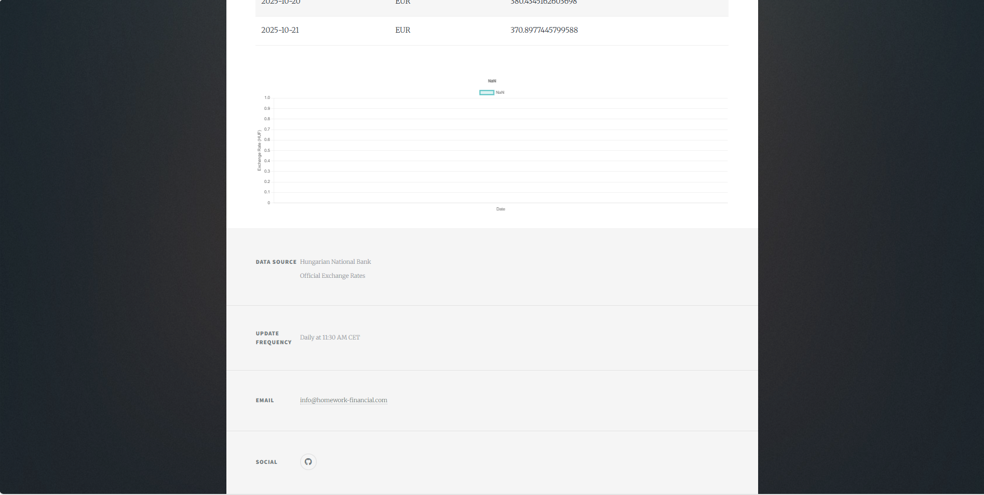

**SOAP Footer**:



# Forex Account Menu

The Forex Account Menu provides an overview of the user’s trading account. It displays key financial information and recent activity in a structured, user-friendly layout.

Displayed Account Information

The page is divided into multiple functional components:

1. **Account Summary Panel:**
   * The page begins with a summary section showing basic account details, such as account ID, type, base currency, status and creation date.
2. **Balance Information**

* Users can view their balance information, current balance, Net Asset Value, **unrealized profit/loss, margin used**, and **available margin**. These values are retrieved dynamically from the backend service.

1. **Trading Statistics**

* Presents key metrics like the number of total trades, winning and losing trades and winning rate. This gives users a quick insight into their trading progress and overall account health.

1. **Activity Table**

* This shows the last four transactions or actions performed on the account. Each record includes the transaction type (e.g., open, close, deposit, trade), the transaction time, the amount and a short description. This helps users easily track their most recent trading operations.

1. **Custom Footer**

* This appears exclusively on account-related pages, providing shortcuts to related operations (e.g., Account Support, Phone, Email, Social).
* This footer ensures consistent page structure across the account management area.

Overall, this menu offers a clear and concise summary of account performance, balance information, and recent activity in a visually organized form.

**Summary Panel and Balance Information**:

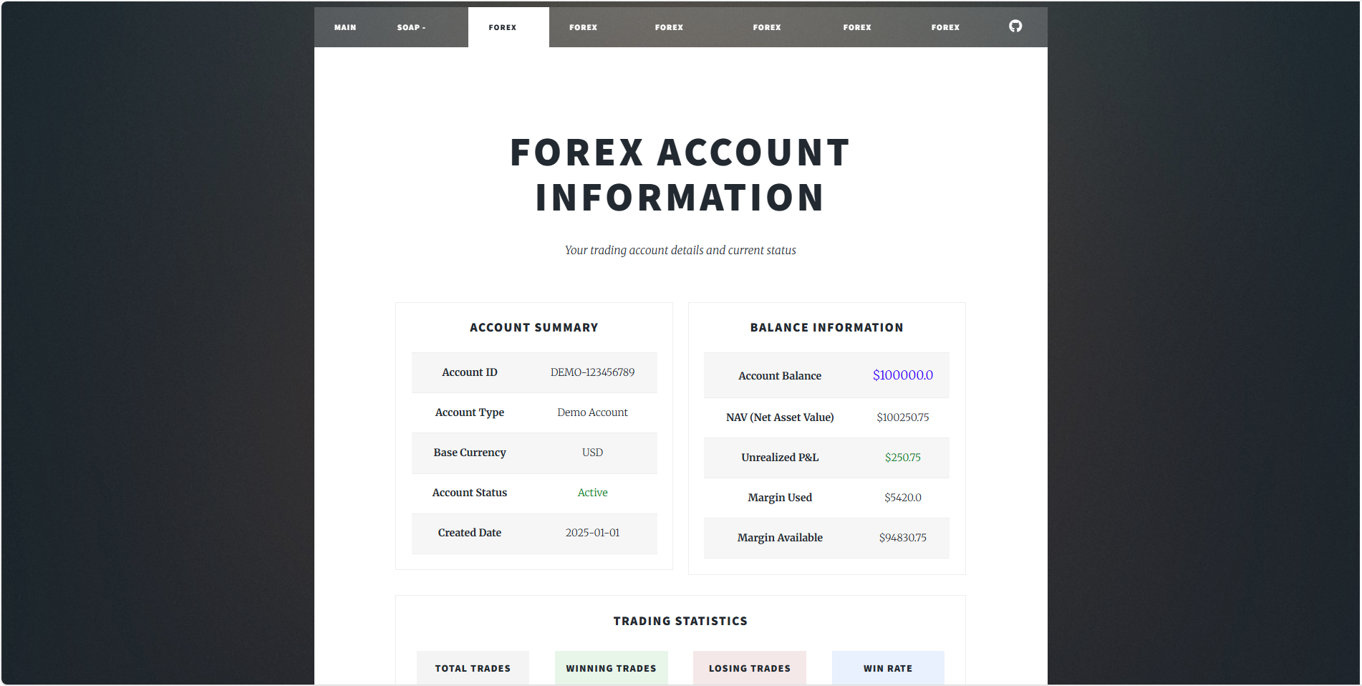

**Trading Statistics and Activity Table**:

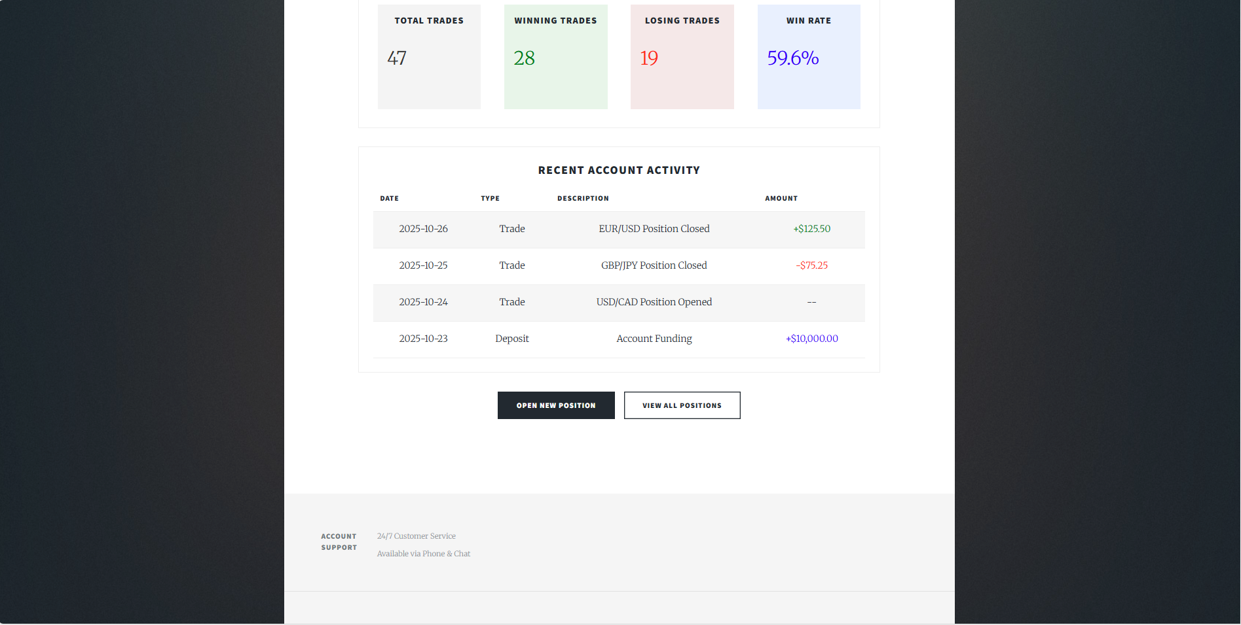

**Custom Footer**:

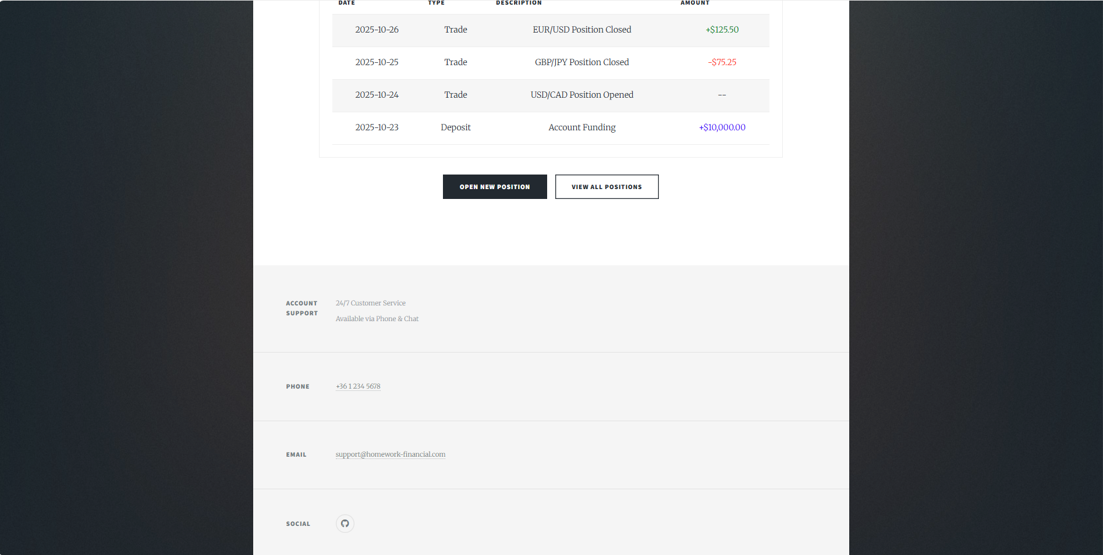

# Forex-ActPrice Menu

The Forex-ActPrice Menu allows the user to select a currency pair from a drop-down list, such as EUR_USD or GBP_USD. After the selection, the system displays the current market price along with two tables showing key details. Trading information table shows spread, min and max trade size and required margin. Market status table show if trading is open or closed, daily high and low and 24hour change.

Below this, a table shows an overview of all available currency pairs. Each pair includes the current price, the 24hour change and an action button that lets the user view more details about that specific instrument.

This menu gives a quick and clear summary of live market data and allows users to easily check and explore current exchange prices.

**ActPrice Drop Down**: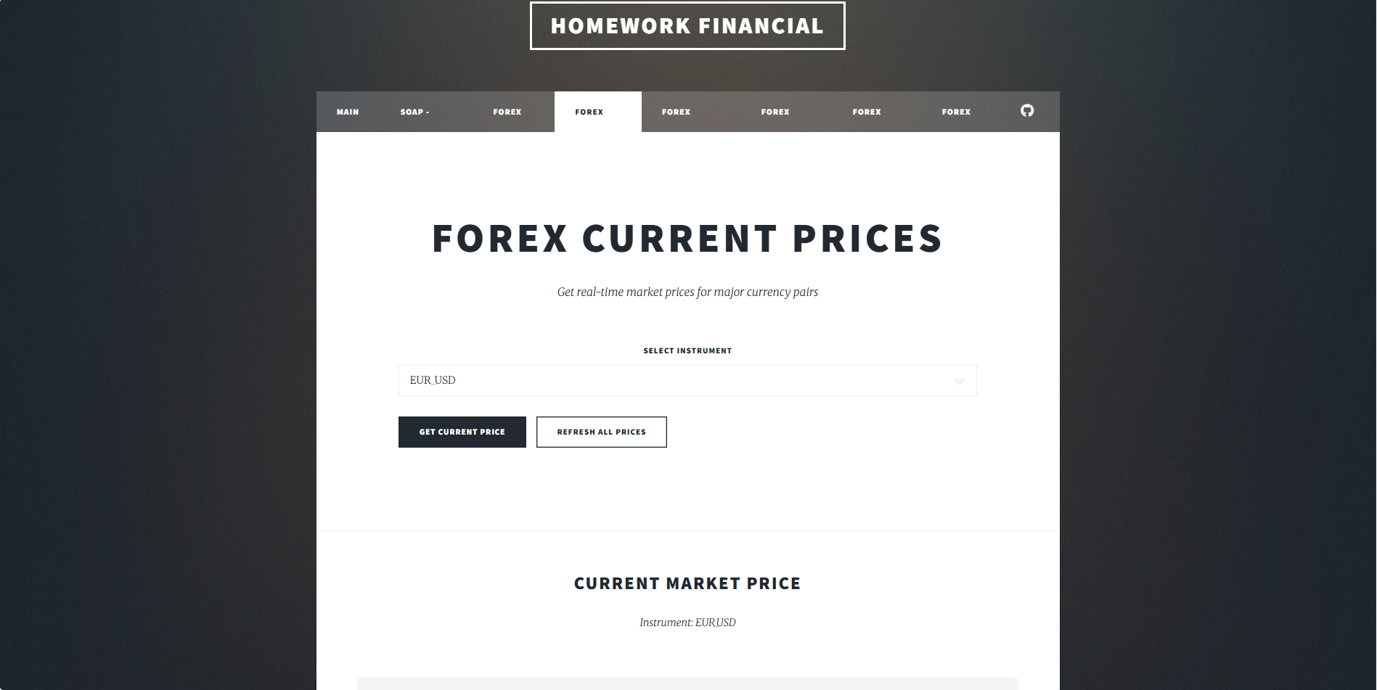

**ActPrice Current market price and tables**:

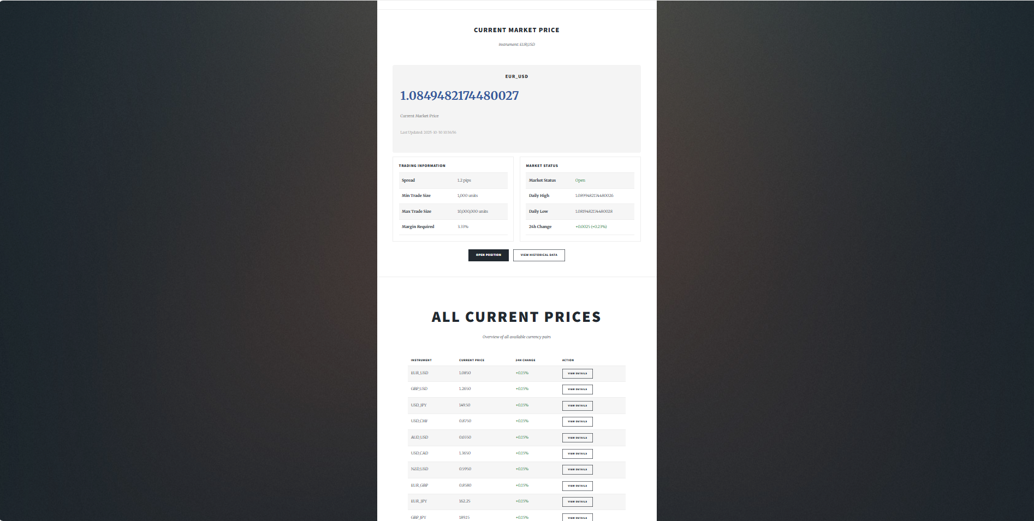

**ActPrice Overview Table**:



# Forex-HistPrice Menu

The **Forex-HistPrice Menu** allows users to view the recent historical prices of selected currency pairs.

On this page, users can choose an **instrument** (for example, EUR_USD or GBP_USD) and a **timeframe** (such as daily or hourly) from two drop-down lists. After making a selection, the system retrieves and displays the most recent exchange rate data for the chosen settings.

The results are presented in a clear and organized table, showing how the currency value has changed over time. This helps users quickly analyze short-term price trends and compare different instruments within the same interface.

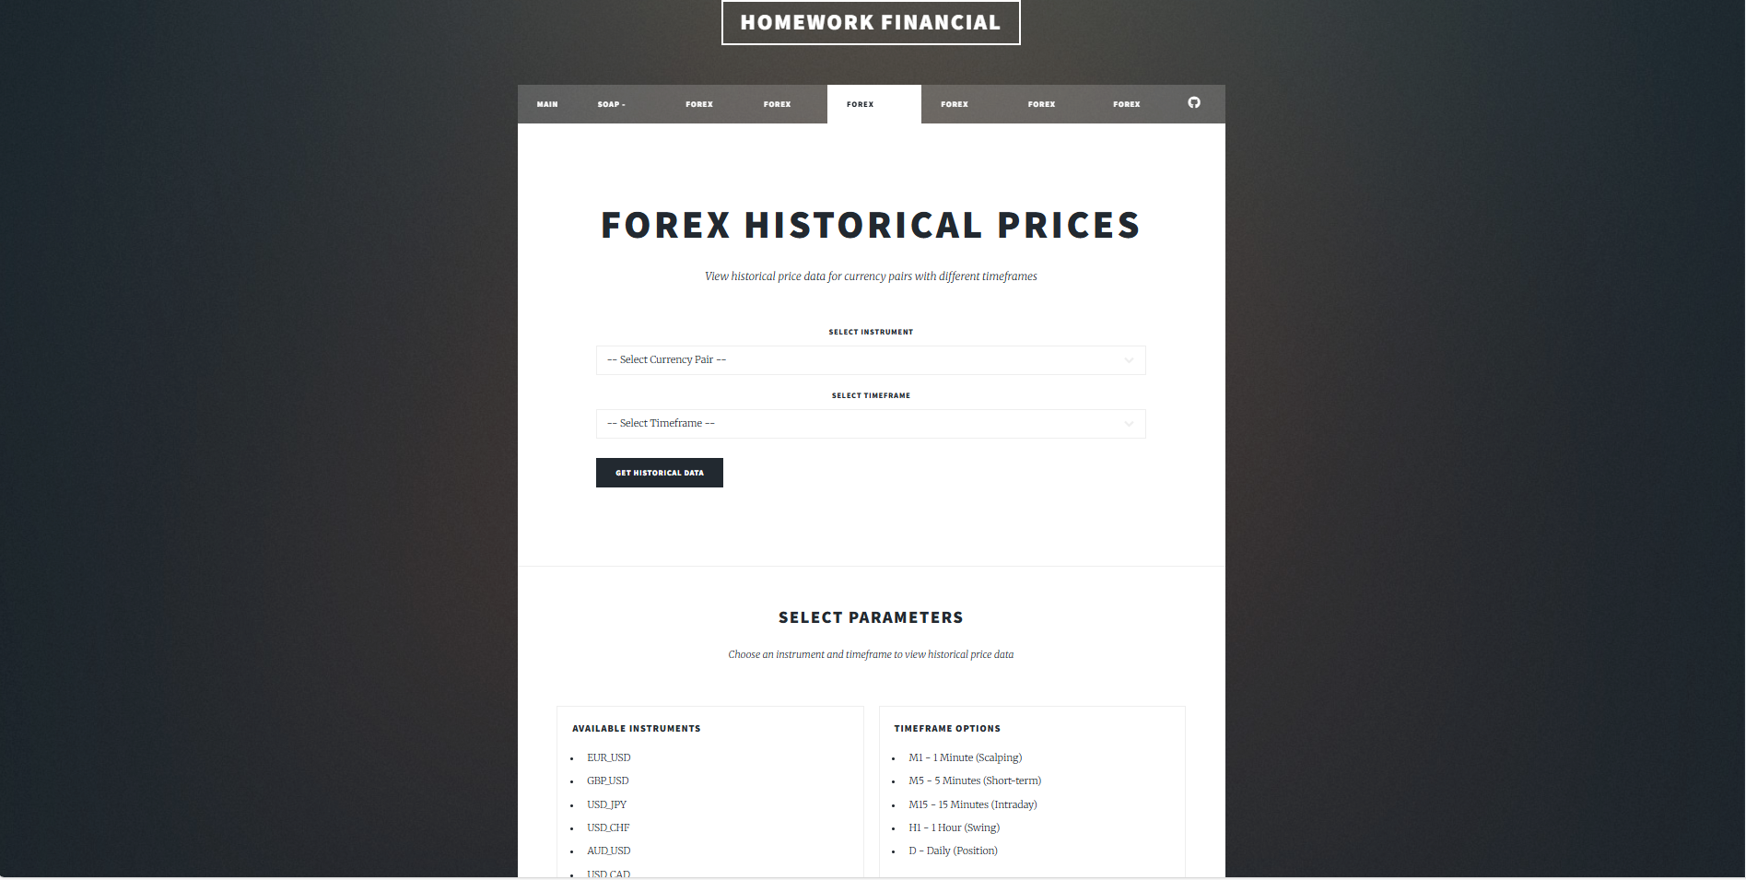

# Forex-Open Menu

The Forex-Open Menu allows users to open new trading positions directly within the site. It provides an interactive form where trading parameters can be customized before executing an order.

At the top of the page, a drop-down list lets the user select the desired instrument (for example, EUR_USD). Below that, there is a quantity input field where the user can specify how many units to trade — positive values represent long (buy) positions, and negative values represent short (sell) positions.

The form also includes optional fields for setting Stop Loss and Take Profit values, allowing the user to manage potential risk and profit targets before submitting the order. An order type selector provides flexibility in choosing how the order will be executed (for instance, at market price or another method).

Under these fields, an Order Summary section displays the details of the current trade setup, along with two buttons: Execute Order to confirm and place the trade, and Reset Order to clear the form and start over.

Below the order form, the page features a section with Trading Guidelines to support users in making informed decisions. This part includes two tables:

* A Position Sizing table
  + shows Standard, Mini, Micro and Maximum Lots.
* A Risk Management table
  + summarizing best practices for maintaining responsible trading strategies.

This menu combines practical trading functionality with educational content, ensuring that each trade can be planned, reviewed, and executed within a single interface.

Interactive Form:

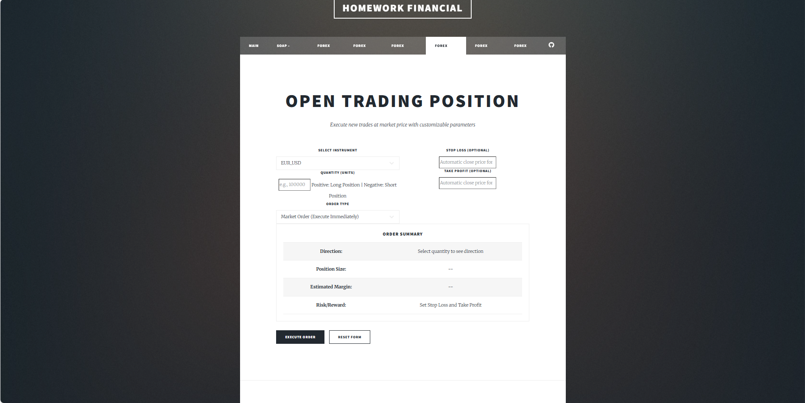

Example of a filled form: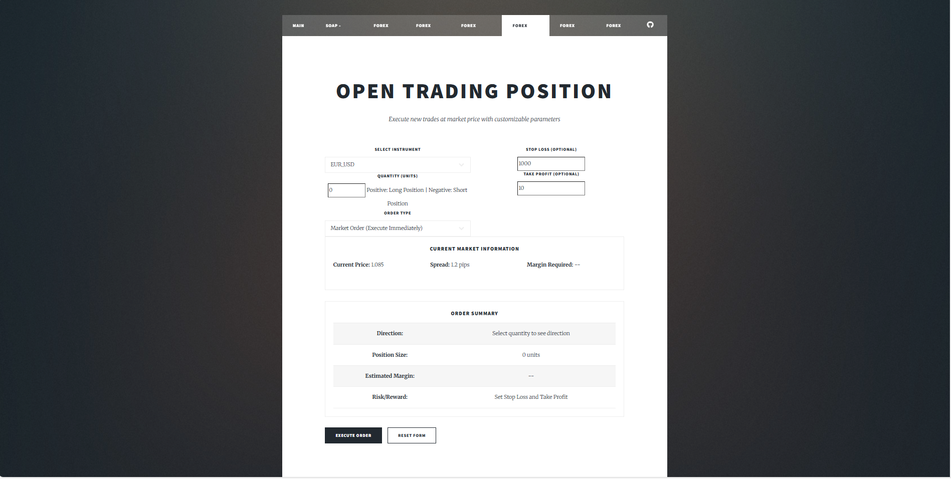

Trading Guidelines:

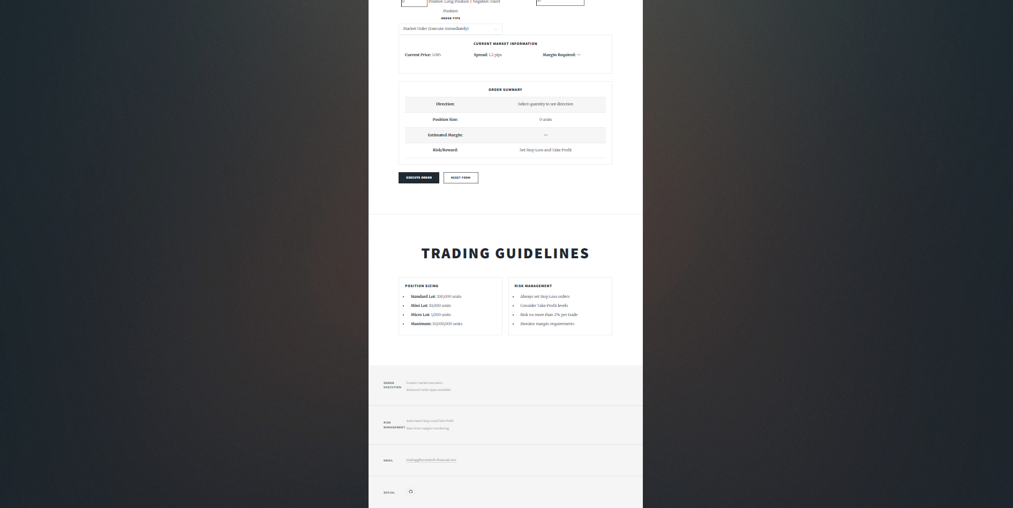

# Forex-Pos Menu

The Forex-Pos Menu provides an overview of all currently open trading positions. It helps users easily track their active trades and view key information in a clear, structured table.

At the top, the page shows the total number of open positions. Below this, a table lists details for each trade:

* Trade ID – a unique identifier for each transaction
* Instrument – the traded currency pair (e.g., EUR_USD).
* Direction – indicates whether the position is Long or Short.
* Quantity– the number of traded units.
* Open Price– the market price at which the position was opened.
* Open Time– the exact time the trade was initiated.
* Status– the current state of the position (e.g., active or closed).

This allows users to quickly understand their current market exposure.

Under the table, there are three buttons that let the user to

* Open a new position
* Close an existing one
* Return to the main menu.

At the bottom, a custom footer contains a simple message form and standard contact information such as address, phone number, email, and social media links, maintaining consistency with other pages.

Open positions table:

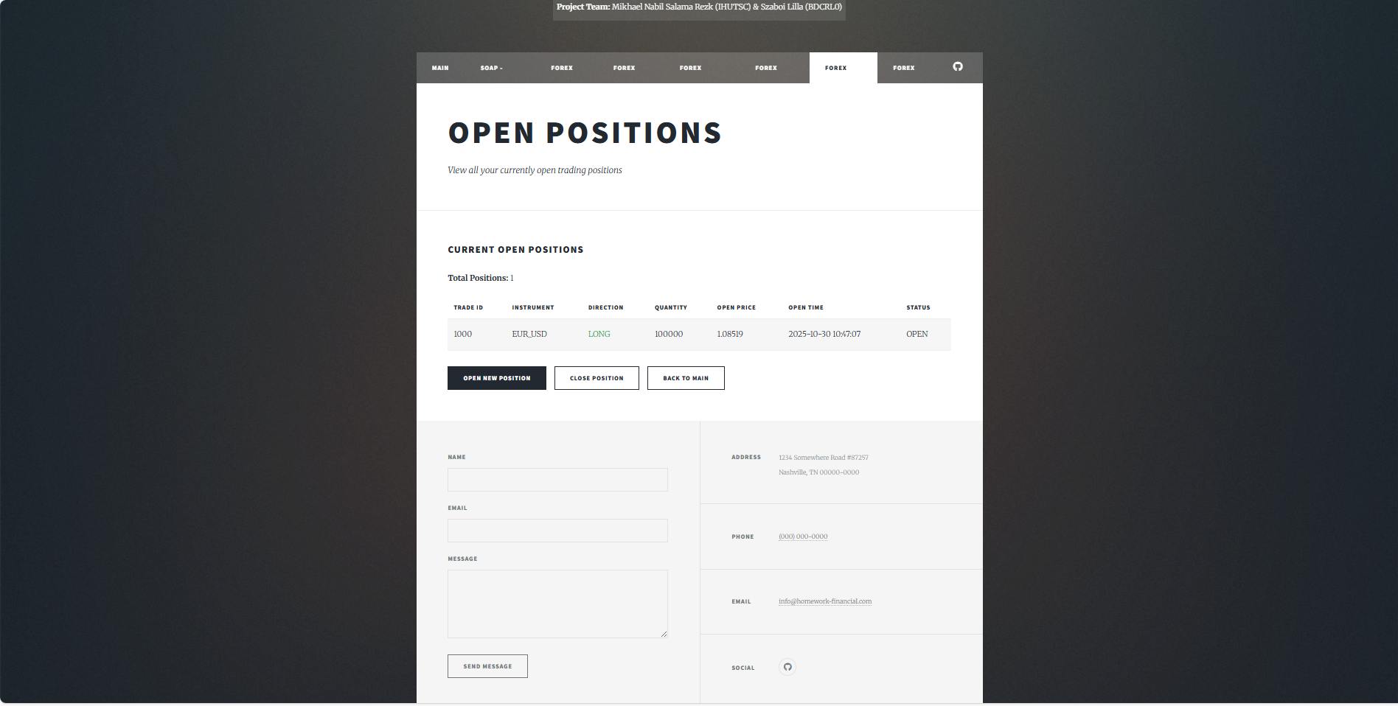

Footer with message form and contact details:



# Forex-Close Menu

The Forex-Close Menu allows users to close an existing trading position by entering its Trade ID. This page provides a straightforward interface for managing open trades efficiently. At the top there is an input field for the ID and two buttons:

* Close Position
* Reset

When a position is successfully closed, a green confirmation message appears above the input field showing the Trade ID, close price, and profit or loss result.

Below the form, an instruction section explains how to properly close a position, helping users understand the process. At the bottom, three navigation buttons provide quick access to related features:

* View Open Positions
* Open New Position
* Back to Main Menu

This menu ensures that trade management remains transparent and user-friendly while maintaining consistency with the overall design of the system.

Closing position with instructions: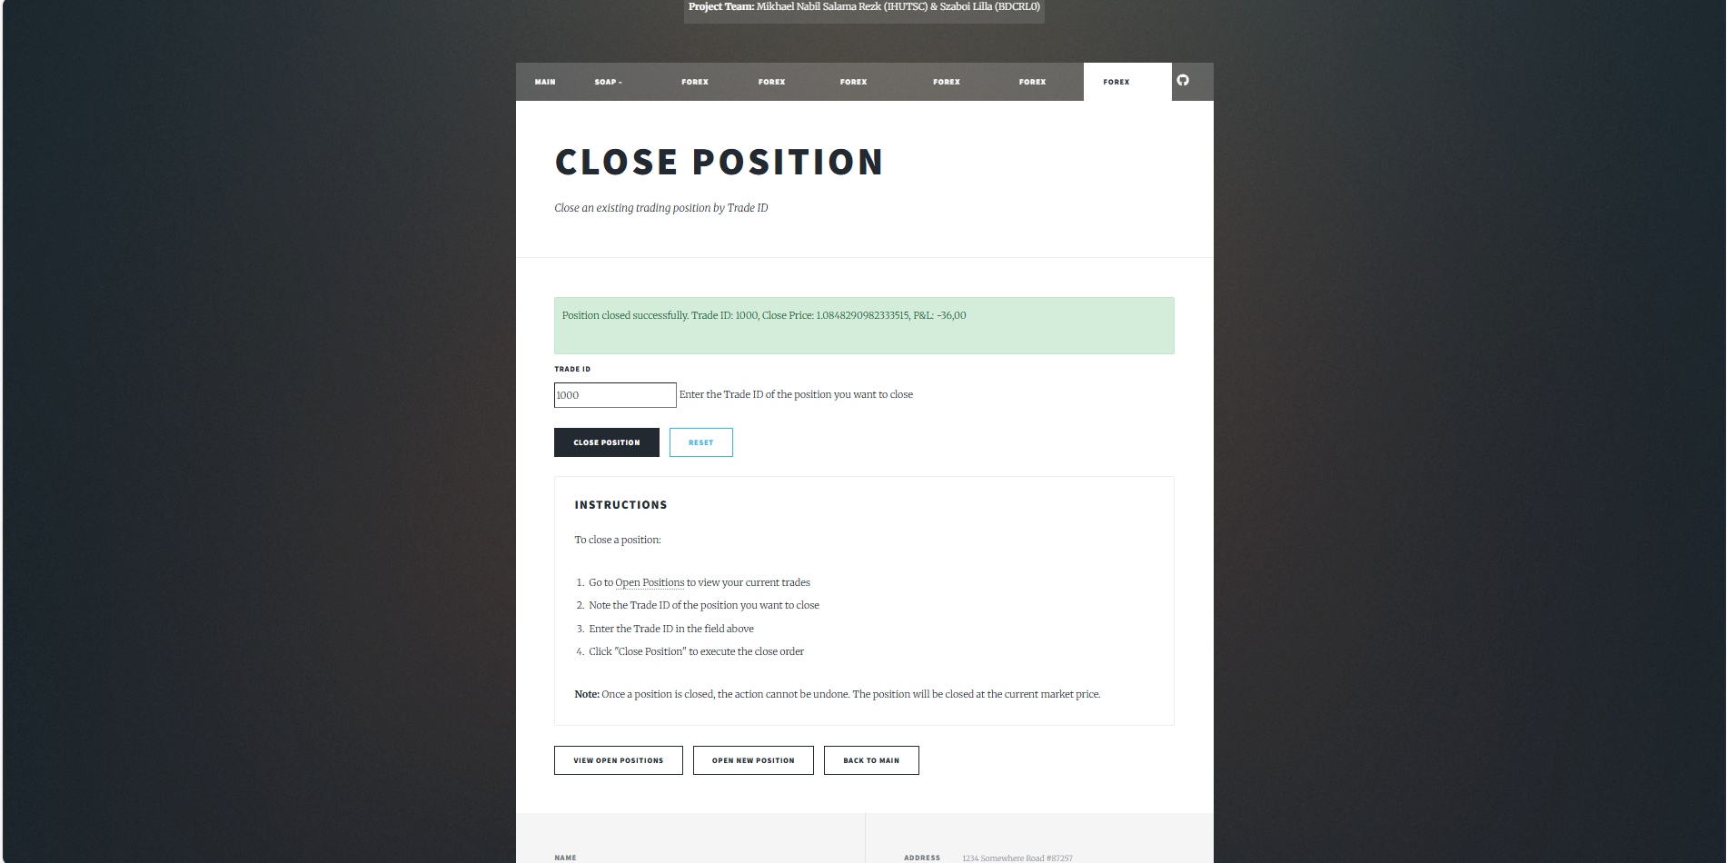

# GitHub Version Control

Version control for the project was managed using GitHub. Although the repository activity shows a single contributor as more active, both group members worked together simultaneously on the same computer throughout the development process.

Because of this shared working setup, most commits were made under one account, even though both members actively participated in designing, coding, and testing the application. The repository still reflects incremental development, with multiple commits documenting different stages of progress and implementation.

*Github repository link*: [BDCRL0/Java-Applications-Lecture](https://github.com/BDCRL0/Java-Applications-Lecture)

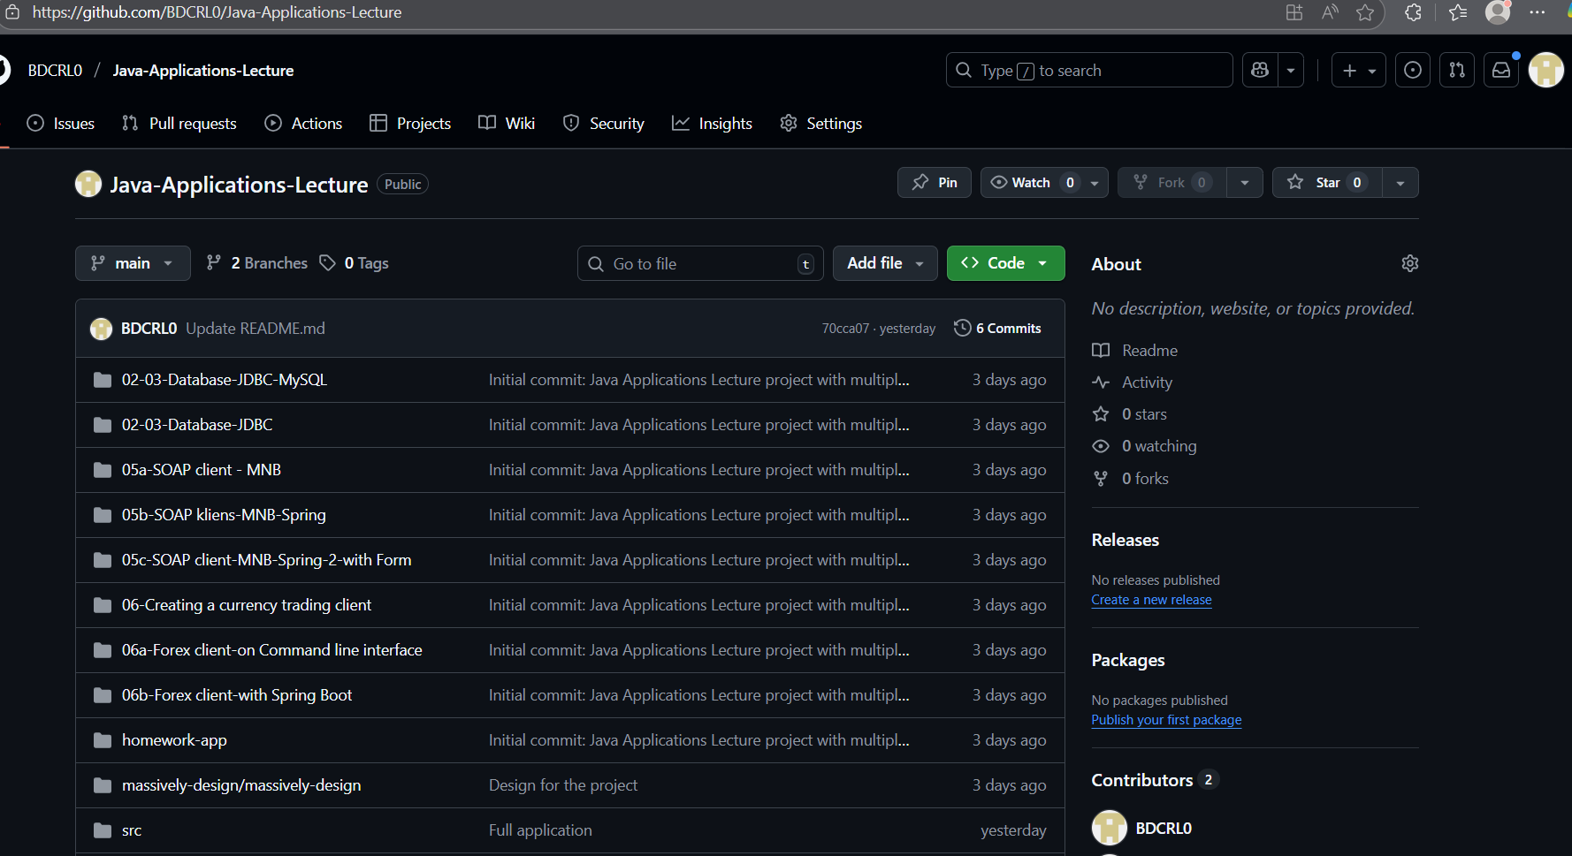

# System Architecture and Implementation Details

The project uses the Model-View-Controller (MVC) architecture provided by the Spring Boot framework:

* Controller Layer – Handles web requests and coordinates between model and view.
* Service Layer – Implements business logic and communicates with external SOAP services.
* Model Layer – Represents application data structures (e.g., CurrencyData, AccountInfo).
* View Layer – Uses Thymeleaf templates for HTML generation and data presentation.

The HungarianNationalBankService class provides methods for connecting to and parsing data from the MNB SOAP service. ForexService manages conversion logic and business rules. Controllers route data to Thymeleaf templates for rendering.

# Testing and Results

Testing included verifying SOAP client connectivity, validating currency rate retrieval, and ensuring accurate data display on the web pages. Screenshots in this document provide visual confirmation of successful execution.  
Unit tests were performed for service methods where applicable, and manual browser testing confirmed UI responsiveness.

# Conclusion and Future Enhancements

The project successfully demonstrates a functional Spring Boot web application with SOAP integration and responsive UI. All mandatory and optional features were addressed. Future enhancements could include database persistence, automated tests, and extended analytics features.